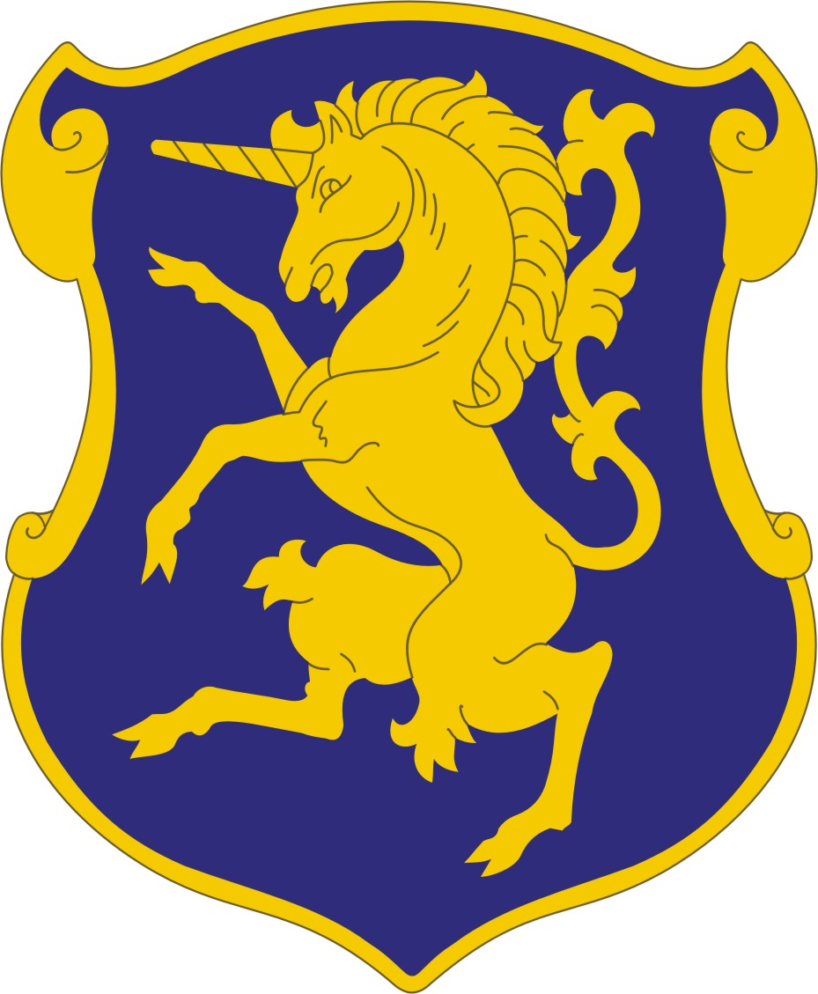

Son and Grandson Membership in 6th U.S. Cavalry Association
Application for full membership in the 6th U.S. Cavalry Association, the association of “The Fighting Sixth” and originating organization of the 6th Cavalry Museum in Fort Oglethorpe, Georgia.

Benefits of Membership: 6th Cavalry Membership Card, newsletter mailed to your home, free admission to 6th Cavalry Museum in Fort Oglethorpe, Georgia and voting privileges.

Your Last Name First Name MI DOB

Mailing Address

City State Zip Code

E-Mail address Area Code & Phone Number

Name of 6th Cavalry soldier you are related to Troop or former Unit – Squadron

His Date of Birth His Date of Death Relationship to you

A short synopsis of yourself:

____________________________________

Annual dues are $25.00, Lifetime dues are $250 made payable to 6th U.S. Cavalry Association. Dues will be refunded in full, if application is not approved.

Make Check Payable to: 6th U.S. Cavalry Association
Mail to: PO Box 5488
Fort Oglethorpe, GA 30742

